**FACULTY OF COMPUTER ENGINEERING**

**PROJECT**

FOR

**DESIGN WITH MICROPROCESSORS**

**-Smart Trashcan-**

**Coordinating teacher: Student name:**

**Rednic Ana Pal Tudor Ovidiu**

**Group: 30234, semestrul I**

**Academic year: 2022-2023**

Table of contents

1. **Table of contents3**
2. **Introduction3**
3. **Bibliographic research5**
4. **Proposed solution and implementation8**
5. **Testing and validation8**
6. **Conclusion9**

### Introduction

For the final project for the “Design with Microprocessors” class, I chose to implement, build, and test a smart trashcan that opens when it detects something above it.

The robot is also able to connect to an android phone and move based on the input given by the user.

I wanted to build this project because I found in my research several smart bins that open when detecting something, but I did not find anything that could also move when given the command to do so and I wanted to find a solution for implementing both these applications on a single robot.

### Bibliographic research

As mentioned above, there already are several robots that do the detecting and opening part, but I tried finding a way to improve them.

Take the following robot for example:

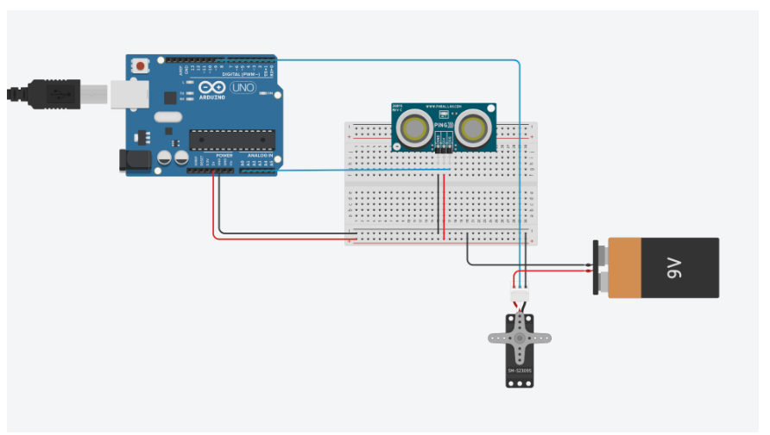

Figure 1 Wiring for a smart Trashcan (https://www.arduino.cc/education/smart-trash-can)

The above robot is a pretty simple design, only using a 9V battery, a 360 degrees servomotor, an ultrasonic sensor, and an Arduino board. Since it uses little resources, the power consumption is very low, and it is easy to implement.

One disadvantage of this method is the limited features it has, compared to other solutions.

Comparing my solution to the aforementioned one, the most noticeable thing is the larger number of components it uses. As a result of this, my robot will have more functionalities that, unfortunately, come with the downside of more consumption power.

### Proposed solution and implementation

For the final project for the “Design with Microprocessors” class, I chose to implement, build, and test a smart trashcan that opens when it detects something above it.

The robot is also able to connect to an android phone and move based on the input given by the user.

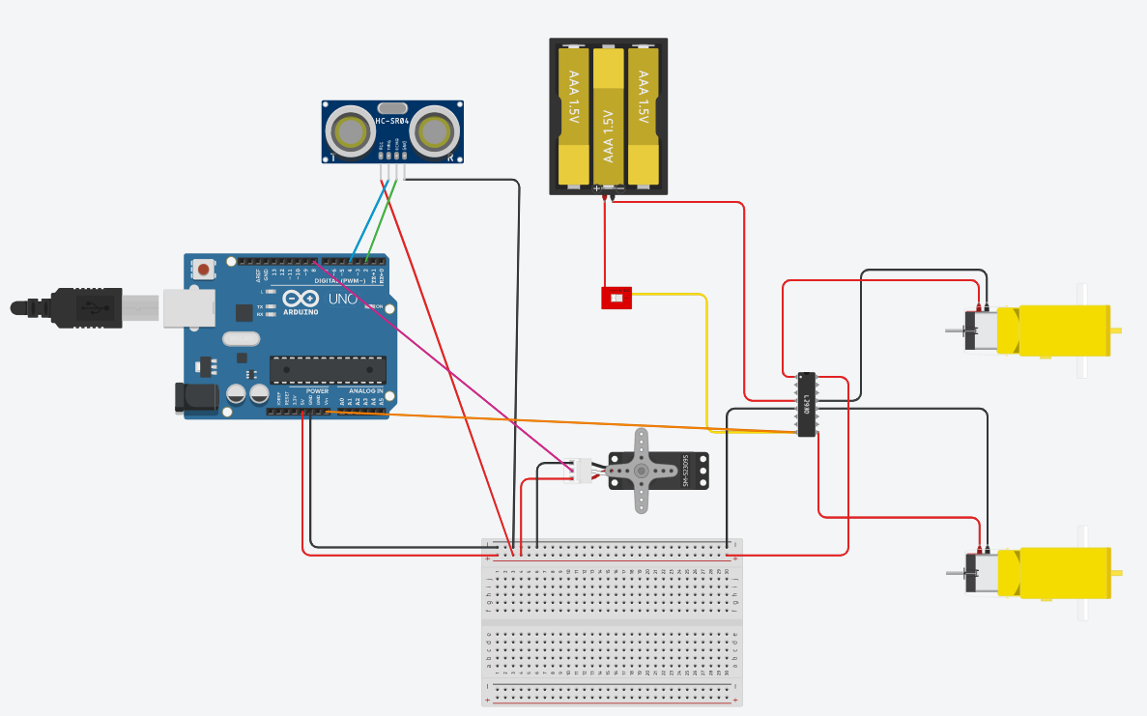

My method uses the following components:

* Arduino board
* Breadboard
* Battery holder (and 4 AA batteries)
* 1 switch
* 2 DC motors
* 1 Servomotor
* 1 Ultrasonic sensor
* 1 L298N H-Bridge
* 1 HC-05 Bluetooth module

I could not find the Bluetooth module to add it to the scheme.

The trashcan is placed on a support on wheels and so, using the Bluetooth module the user can send inputs and the trashcan moves based on those inputs. The ultrasonic sensor is placed on the trashcan, facing upwards to activate the servo motor which pushes the pedal down, thus opening the trashcan lid.

To fit the trashcan on wheels, I needed to create a hand-made support.

### Testing and validation

Before putting everything together, I tested every component alone in order to assure their correct functionalities.

The first hardware issue I ran into was a power switch deteriorating and having to replace it.

For software issues, the main one was that the code was not compiling when the RX and TX from the Bluetooth module were connected to the Arduino board, so I had to remove them when uploading the code and then reconnecting them.

The hardest part for me, was making a design that fit the trashcan and also that was able to sit on wheels.

### Conclusion

I would like to continue working on this project and making everything more hazard proof and more beautiful to the eye, as it currently has wires everywhere and it is easy to break.

It was a great learning experience and I wish to improve my robotics skills in the future in order to make bigger and greater projects.